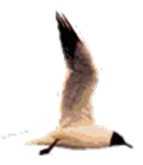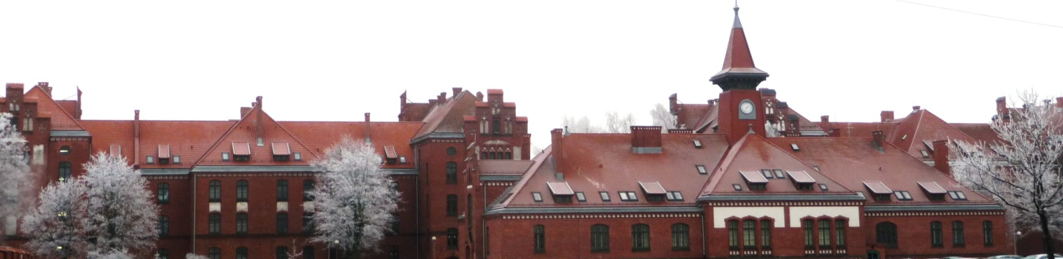
OSRESS 2018
OUTDOOR SPORTS AND RECREATION EDUCATION SUMMER SCHOOL 2018

Recreational Physical Activity in Lithuanian Seaside Resort
Klaipeda, Lithuania
September 6, 2018

Organizers:
Department of Physical Education,
Klaipėda University , Lithuania

in collaboration with:
Latvian Academy of Sport Education (LASE)
Latvian Association of Outdoor Education and Recreation (LAOER)
Jozef Pilsudski University of Physical Education in Warsaw, Faculty of PE in Biala Podlaska, Poland
University of Malaga, Spain
St.Cyril and St.Methodius University of Veliko Tarnovo, Bulgaria
Lithuanian University of Educational Sciences
Vilnius University, Lithuania
Scientific and Organizing Committee:

Dr. prof. Asta Sarkauskiene, Head of Summer School, Klaipeda University

Dr. Vyte Kontautiene,
Klaipėda University

Dr. assoc.prof. Asta Budreikaite,
Klaipėda University

Dr. Rolandas Janciauskas,
Klaipėda University

Dr. prof. Juris Grants,
Latvian Academy of Sport Education (LASE) and
Latvian Association of Outdoor Education and Recreation

Dr. assoc. prof. Ivars Kravalis
Latvian Academy of Sport Education

Dr. assoc. prof. Inta Bula-Biteniece
Latvian Academy of Sport Education

dr. assoc. prof. Ingrida Smuka
Latvian Academy of Sport Education

Dr. prof. Johnny Nilsson
Swedish School of Sport and Health Science (GIH), Sweden

Dr. assoc. prof. Krzysztof Piech,
Josef Pilsudski University of Physical Education, Biala Podlaska, Poland
Dr. assoc. prof. Artur Litwiniuk
Josef Pilsudski University of Physical Education, Biala Podlaska, Poland
Lomza State University of Applied Sciences, Poland

Dr. prof. Oskar Romero Ramos
University of Malaga, Spain

Dr. prof. Rafael Merino Marban
University of Malaga, Spain

CONFERENCE PROGRAM
9.00-9.30
Opening of the conference. Welcome word.

9.30-10.05
Presentation of universities (each university 5-6 minutes).

10.05-10.35
Sport science in the framework of the LASE Journal of Sport Science and the Baltic Sport Science Society
Dr. prof. Juris Grants (LV)
LASE (Latvian Academy of Sport Education)

10.35-10.55
Measurement of physical activity and component of positive health population EU
Dr. assoc. prof. Artur Litwiniuk (PL),
dr. prof. Juris Grants (LV),
Valdemaras Kavaliauskas (LT)

10.55-11.15
The adolescents sports tourism in Lithuania: a pedagogical approach
Dr. prof. Asta Šarkauskienė(LT)
KU (Klaipeda University, Lithuania)

11.15-11.35
Posture - the mirror of life balance
Dr. prof. Ruta Dadeliene (LT)
VU (Vilnius University, Lithuania)

11.35-11.50
Body building and body posture - safe and risky behavior for our spine in daily activities
Dr. assoc. prof. Malgorzata Lichota (PL),
AWF (Josef Pilsudski University of Physical Education), Biala Podlaska, Poland

11.50-12.10
Traditional games and plays from southern Podlasie as an element of cultural heritage
Dr. assoc.prof. Krzysztof Piech (PL),
Dr. assoc. prof. Anna Bodasińska
AWF (Josef Pilsudski University of Physical Education), Biala Podlaska, Poland

12.10-12.25
Vibrostimulation in sport
Dr. assist. of prof. Kalvis Ciekurs (LV)
LASE (Latvian Academy of Sport Education)

12.25-12.45
Sports for all event in Lithuania and other recreational physical activities
Dr. assoc. prof. Donatas Gražulis (LT)
LEU (Lithuanian University of Education Sciences)

12.45-13.10
Recreation Qualification Program at Masters programme in LASE
Dr. assoc. prof. Ivars Kravalis (LV)
LASE (Latvian Academy of Sport Education)

13.10-13.25
Summary of the conference
Closing conference

